Based on the textbook concepts provided in your slides and the details of the "Life is good" case study, here is an analysis of the specific challenges Bert and John face, as well as the management functions most and least critical to their roles as top managers.
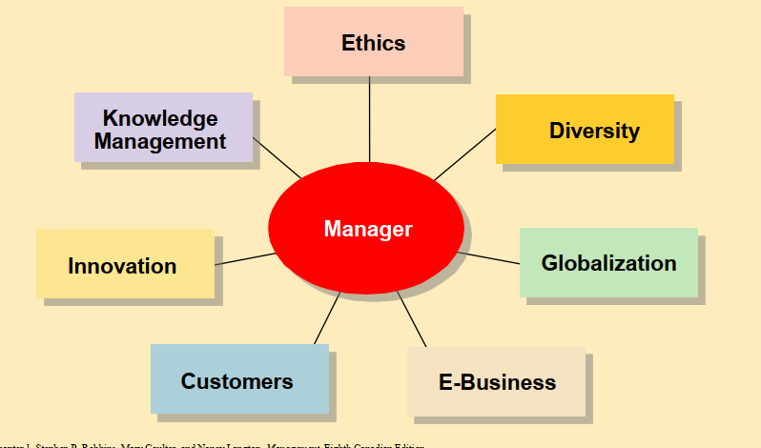
Part 1: Issues and Challenges Impacting Bert and John
As top managers of a rapidly growing company ($100 million in revenue with 30-40% annual growth), Bert and John must navigate several of the specific challenges outlined in Exhibit 1.9:
- Innovation: Your slides define this as "doing things differently, exploring new territory, and taking risks." Bert and John grew from selling shirts out of a beat-up van to managing a product line of over 900 items. Their core challenge is encouraging innovation to sustain their massive growth while ensuring new products still align with the simple, humorous "Jake and Rocket" brand identity.
- Customers: The slides note that "delivering consistent high-quality service is essential" and managers must create "customer-responsive organizations." Because their entire brand promise is literally "Life is good," poor customer service would immediately break trust. They face the challenge of ensuring every retail and online interaction reflects the brand's optimistic outlook.
- Ethics: With the creation and funding of the Life is good Kids Foundation and their partnership with Project Joy, Bert and John face the ethical challenge of transparently managing corporate philanthropy. They must ensure that the funds raised through festivals and specific product sales are properly allocated and that their apparel is ethically sourced.
- E-Business: To handle a product line of 900+ items and rapid growth, they must utilize e-commerce. They likely face the challenge of transitioning into an E-business–enhanced organization, where they must integrate robust electronic sales and marketing components (e-commerce) into their traditional retail model to reach customers beyond their physical stores.
- Globalization: As a $100 million company, they inevitably face the "political and cultural challenges of operating in a global market." This includes managing international supply chains for their apparel manufacturing and potentially expanding their sales footprint outside of the United States.
- Knowledge Management & Diversity: They started by hiring friends, but a $100 million company requires a large, diverse workforce. They face the challenge of "workforce diversity" (integrating varying backgrounds into a unified culture) and Knowledge Management—specifically, building a "learning organization" where the foundational knowledge of their unique, carefree corporate culture is systematically shared with hundreds of new employees who weren't there in the early days.

Part 2: The Functions of Management
The Most Important Functions: Planning and Organizing
As top-level executives, Bert and John must focus heavily on the macro-level structure and future of the company.
- Planning: The slides define planning as "defining goals, establishing strategies to achieve goals, developing plans to integrate and coordinate activities." This is critical for Bert and John. They must define the long-term strategy required to sustain their 30% to 40% annual growth. They have to plan how to enter new markets, when to introduce new product lines (expanding beyond 900 items), and how to strategically integrate their philanthropic goals (Project Joy) with their revenue targets.
- Organizing: Defined as "arranging work to accomplish organizational goals." Moving from a card table in Boston to a $100 million corporate entity requires massive organizational structuring. Bert and John must decide how to divide departments (e.g., separating the retail division from the corporate and foundation divisions), establish reporting hierarchies, and allocate corporate resources efficiently.
The Less Important Functions (At the Top Level): Leading and Controlling
While all managers perform all four functions, Leading and Controlling become less hands-on and less immediately critical for top managers compared to middle and first-line managers.
- Leading: The slides define this as "working with and through people to accomplish goals." While Bert and John are the symbolic leaders who set the cultural tone ("Do what you like. Like what you do"), they do not have the time to manage the daily interactions of the workforce. Directing individual subordinates, resolving daily shift conflicts, and selecting or training individual retail employees are tasks they must delegate to middle management.
- Controlling: Defined as "monitoring, comparing, and correcting the work." Top managers look at macro-level controls (like quarterly profit margins or overall annual growth). However, the day-to-day micro-controlling—such as monitoring the quality of the stitching on a batch of t-shirts, tracking the daily attendance of warehouse staff, or correcting a specific customer service complaint—is not a valuable use of a top manager's time. They rely on the systems they established during the Organizing phase to handle these issues.

